Creating accumulation register

The object *Accumulation register* is intended to describe the structure of data accumulation. Based on the РегистрНакопления object, the platform creates tables in the database in which data supplied by various database objects will be accumulated. This data will be stored in tables as separate records, each of which has the same structure.

Let's imagine, that we are interested in information about how much and what kind of materials we have in our warehouses. To accumulate such information, we will create a register Remaining materials.

In development mode

Let's open the system in development mode and add a new object *Accumulation register*.

To do this, select the Accumulation registers branch in the object tree and click the Add button in the command panel.

In the opened object editing window, on the Main tab, we will set the register name – ОстаткиМатериалов.

We will also define the Representation of the list as Movements by the Material Remaining Register. This title will be displayed in the register entry list window.

Click Next and go to the Subsystems tab.

According to the logic of our configuration, this register should be available in the sections Accounting of materials, Rendering services and Accounting. Therefore, we will mark these subsystems in the list of subsystems (pic. 6.3).

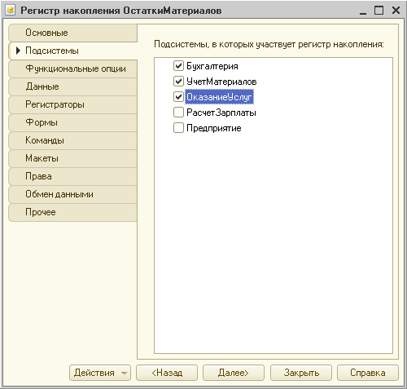

**pic. 6.3.** Defining the list of subsystems in which the register will be reflected

We will select the Data tab and proceed to creating the register structure. We will create register attributes:

Материал, type СправочникСсылка.Номенклатура;

Склад, type СправочникСсылка.Склады;

Количество, type Число;

To do this, select the branch Dimensions and click the button Add in the command bar of the window (Pic. 6.4).

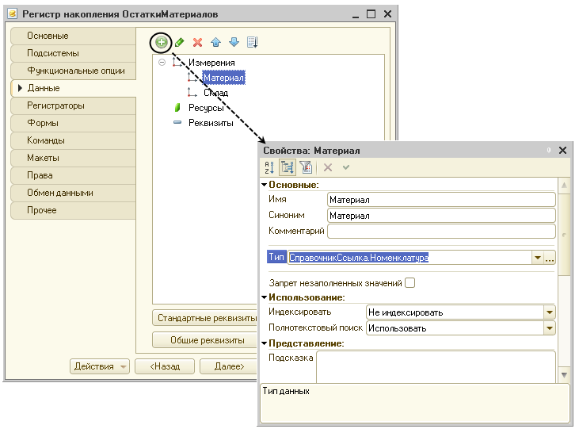

**pic. 6.4.** Creating register dimensions

As a result of these actions, the register ОстаткиМатериалов should have the following appearance (pic. 6.5).

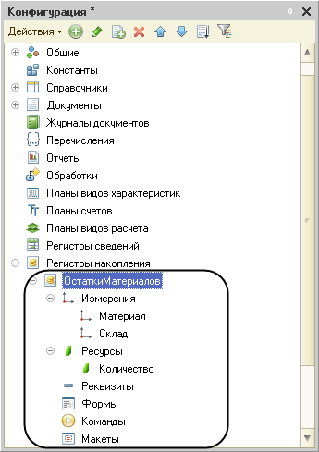

**pic. 6.5.** Register "ОстаткиМатериалов"

If you now try to start the system in user mode, the system will return an error message: "РегистрНакопления.ОстаткиМатериалов: None of the documents are registrars for the register." This message once again confirms the fact that the purpose of the accumulation register is to accumulate data supplied by other documents.

Therefore, we will form the movements of the accumulation register ОстаткиМатериалов for two documents we created ПриходнаяНакладная and ОказаниеУслуг.

Document movements

*Document movements* are records in registers that are created during the process of document posting and reflect the changes made by the document.

Let's open the window for editing the object Документ.ПриходнаяНакладная. We will go to the Movements tab, open the Registers Accumulation list and mark the accumulation register ОстаткиМатериалов (pic. 6.7).

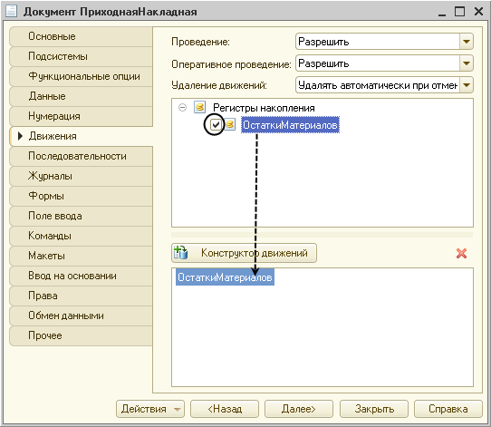

**pic. 6.6.** Creation of document movements “ПриходнаяНакладная” in the register “ОстаткиМатериалов”

Please note that immediately after marking the selected register, the Movement Constructor button becomes available. We will click it and use this constructor. We will click the Fill expressions button. In the lower window, a correspondence will be formed between the attributes of the register and the document. The movement constructor has set the correspondences in the appropriate way: the material from the document's tabular section will be recorded in the register as the material, the warehouse specified in the document's header as the warehouse, and the quantity from the document's tabular section as the quantity.

We will press the OK button and see what text the designer generated in the document ПриходнаяНакладная (listing 6.1).

**Listing 6.1.** Процедура "ОбработкаПроведения()"

Процедура ОбработкаПроведения(Отказ, Режим)

//{{__КОНСТРУКТОР_ДВИЖЕНИЙ_РЕГИСТРОВ

// Данный фрагмент построен конструктором.

// При повторном использовании конструктора внесенные вручную

// изменения будут утеряны!!!

// регистр ОстаткиМатериалов Приход

Движения.ОстаткиМатериалов.Записывать = Истина;

Для Каждого ТекСтрокаМатериалы Из Материалы Цикл

Движение = Движения.ОстаткиМатериалов.Добавить();

Движение.ВидДвижения = ВидДвиженияНакопления.Приход;

Движение.Период = Дата;

Движение.Материал = ТекСтрокаМатериалы.Материал;

Движение.Склад = Склад;

Движение.Количество = ТекСтрокаМатериалы.Количество;

КонецЦикла;

//}}__КОНСТРУКТОР_ДВИЖЕНИЙ_РЕГИСТРОВ

КонецПроцедуры

In user mode

Let's run the system in user mode and test the changes we've made.

In the window that opens, we see that in the function panel of the sections Accounting, Services and Accounting of materials at the end of the list of commands for opening various lists, before the submenu Create, Reports (if they exist) a command has appeared for opening the register list Material balances (pic. 6.8).

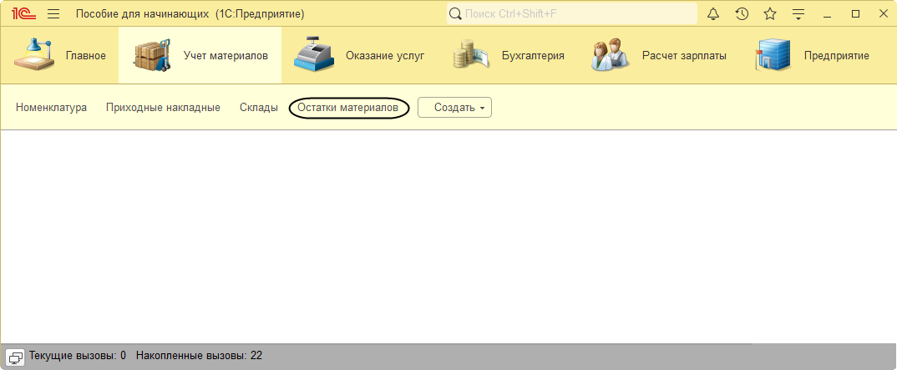

**pic. 6.7.** List of accumulation register "Remaining materials"

Glossary

*Document movements* are records in registers that are created during the process of document posting and reflect the changes made by this document.

*Accumulation register* is an object intended for describing the structure of data accumulation.